Yvonne Bates

July 2012

Dr. Hearrington

Fall 2010

Engaging Student Learning with Smartboard Integration

Description of Capstone Experience:
My Capstone Project took place at Teasley Elementary, where I teach first grade. The need at Teasley Elementary is one of incorporating technology through the use of Smartboards at a higher level of learning. The intention of the project was to reflect on teacher-directed instruction and objective alignment with student activities that demonstrate “a teaching and learning where more complex kinds of knowledge and cognitive processes are involved” by using the Taxonomy Table as described in Krathwohl’s Revision of Bloom’s Taxonomy (Krathwohl, 2002). I chose six participants, one teacher from each grade level, to help me with this project. I asked teachers for their help based on their amount of knowledge and expertise with the Smartboard, as well as their comfort level with the Smartboard and technology. Some teachers I knew were right on the verge of fully integrating the Smartboard, while others may not have as much experience, but were eager to learn more. A couple of the teachers were chosen because they are not as comfortable and do not integrate as much technology and I wanted to see if I could help them. The table below provides some participant information.
Participants Chosen to Help with Project
Grade Level/Teacher: | Smartboard Use: | Attitude/Teaching Style:
K (Ms. S) | Some Use | Ready/Willing to learn more
1 (Ms. D) | Frequent Use | Willing to go beyond how it is already being used
2 (Ms. P) | Some Use | Ready/Willing to learn more
3 (Ms. M) | Some Use | Not as tech savvy, but willing to try something new
4 (Mr. B) | Used only for Projection | Not as tech savvy, but willing to try something new
5 (Ms. T) | Frequent Use | Willing to go beyond how it is already being used

I met with the teacher participants to show them the Revised Bloom’s Taxonomy and explained what I would be looking for when observing in their classrooms. None of them were aware of the revisions made to the Bloom’s Taxonomy that we have seen for years. They had the opportunity to ask questions, most wanting to know what exactly I wanted to see. I let them know that for the initial observation I just wanted them to teach a normal lesson in a content of their choosing that also included integration of the Smartboard. I wanted to see how an everyday lesson would look. We set up initial observations for the month of September so that the teachers and students had a chance to settle in to the school year.
Initial Observations:
The initial observations started, as planned, in mid-September. I was able to leave my classroom and observe in the other classes because I co-teach. My co-teacher and I planned activities for our students to do where I was not needed for the 30 minutes that I would be observing. This was a great benefit for me and allowed me the opportunity to meet with the participants for this project.
I observed in each class for 30 minutes at a time. I wrote down everything that the teacher was doing, how the Smartboard was being used, and what the students were doing during the lesson. Each observation will be detailed to show the teacher name, grade level, subject being taught, Smartboard use, lesson activity, and the amount of student interaction. The goal for the teachers was to have an activity involving the students that was on the right side of the Revised Bloom’s Taxonomy, from the analyze level to the create level, and toward the lower right quadrant in knowledge with procedural and meta-cognitive being best. That would show the highest level of knowledge and cognitive processing being attained, and therefore would be the most engaging level for the students. As the Revised Bloom’s Taxonomy Table shows:
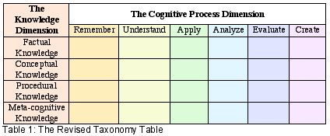
I also thought it was important to indicate whether the Smartboard and other technology being used for the lesson were working properly at the time of the observation.
Ms. S (Kindergarten) was teaching a language arts lesson for writing. She had created a Smartboard slide with handwriting lines as well as a large, empty rectangle at the top for her picture. She was modeling by writing about what she had done over the weekend. Students were interacting with the teacher by answering her questions: “How do we spell…”, “What kind of letter should this be?” “What do we need at the end of our sentence?” etc. Students stayed engaged in the learning by answering the teacher questions and using hand gestures they had learned to indicate a capital letter, a period, and a finger space. After the teacher finished modeling her writing, she sent students back to their seats to write in their journals and telling them to make sure they included: the date, title, a picture, capital letters, finger spaces, periods, and all spelling words spelled correctly. Based on the Revised Bloom’s chart, Ms. S’s engagement score was a level A3, which indicates the lowest level of knowledge (factual) but in the application level of the cognitive process. Within this lesson the students had no interaction with the Smartboard themselves. They watched the teacher and responded to what she was doing. All technology for this lesson was working properly during the observation.
Ms. D (1st grade) was using the Smartboard and ELMO to project the morning work on the screen for students to go over as a class. After that, she started a math lesson on fact families. She had drawn a house on the Smartboard with lines to show where numbers would go to make the addition and subtraction number sentences to make up the fact family. Students were called up to the front one at a time to write a number sentence that would go with the fact family numbers given. The rest of the class checked and indicated if the student was correct. There were six fact family houses completed before students were introduced to a pocket chart that looked similar to what they had just practiced on the Smartboard. The teacher explained that the chart would be used during center time. A couple of students were chosen to show a problem using the chart to make sure everyone knew what to do next. Based on the Revised Bloom’s chart, Ms. D’s engagement score was a C3, which was procedural knowledge and application in the cognitive process. This was a good beginning score which was in a higher level of knowledge and toward the middle range in cognitive processing.
Ms. P (2nd grade) was using the Smartboard to display a test and the students were using their student response remotes to enter their answers into the I-Respond data software. Ms. P gave explicit directions on how to use the “clickers” before starting the test and when needed during the test. She was also able to troubleshoot during the test to get students back on track when the wrong button was pressed. Students were engaged during the entire activity because they needed to check their test and then make sure the correct answer was clicked on the remote. The student engagement level for this lesson was at C3, procedural application. This is a good beginning score and the students were engaged the entire time. All technology, the Smartboard and the student remotes, were working during the lesson.
Ms. M (3rd grade) was going over a math worksheet with her students. The Smartboard was displaying a math page from the Harcourt Math website and the students were going up to the board to work the problems. The ink layer was used to fill in the problems on the page. Students were explaining their work as they wrote. Students in their desks were supposed to watch, listen, and make sure their answers were correct based on the student work being displayed on the board. One student was too short to reach where the math problem was displayed, so another student went and got a stool for him to stand on. This was a troubleshooting tactic the students had obviously worked through before. The next part of the lesson was exciting for me because the teacher pulled up an activity from the Smart Exchange website that she learned at the professional development course I had taught the previous week. The activity was on money and the students had to move the coins to the cash register in order to “pay” for the item they were shown. Ms. M told the students that this site would be up for everyone to work on during center time. Some students were interacting with the board while others watched. The students were more engaged in the learning when the new money site/game was brought up and were high-fiving and clapping when they were told they could work on the site more during centers. I scored Ms. M’s level of engagement for the money activity as a C4, which was procedural knowledge and analyzing in the cognitive process. Students were engaged the most during this activity. They used their knowledge of the board and money to then analyze how to best solve the problem using the coins given. This was a great lesson. All technology was working during this observation.
Mr. B (4th grade) was teaching a language arts lesson on fact and opinion. He used the ELMO to project a paragraph up on the Smartboard. He asked students to find phrases that were facts and he used a highlighter pen to highlight the paper as the students watched from their seats what was being displayed. This lesson scored an A2 which is on the understanding level of factual knowledge. Most students were paying attention and were engaged somewhat in the learning, but there was no interaction between the students and the board at all. All technology was working during this lesson.
Ms. T (5th grade) was in the middle of a math minute activity when I came in to watch her lesson. An electronic timer and a math problem were displayed on the board and the students were writing their answer on a scrap piece of paper to be turned in before the minute was up. Two students’ answers were chosen from the bowl, where they turned them in, and they got to explain how they came up with their answer and received a sucker for being correct. During the next part of the lesson, Ms. T used the Smartboard to display a background of graph paper as she taught a lesson on modeling multiplication of decimals. While she displayed her work on the board, students used their own piece of graph paper and colored pencils to work the problems. After practicing together, student were given problems to work on their own and then called to the front to show their work using the Smartboard. The student engagement in this lesson scored a C4 which is using procedural knowledge and analyzing in the cognitive process. Students were engaged in the lesson the entire time of the observation and were actively working on paper and on the Smartboard. I really enjoyed watching this lesson. All technology was working correctly.
So after the initial round of observations, here is where the teachers stood on student engagement with the Smartboard:
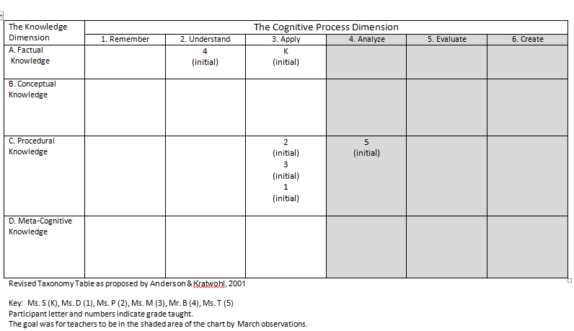
Most of the teachers were right on the verge of crossing over into the shaded portion on the chart, which was the goal. I was positive that after our follow-up meetings we could figure out how to make sure the final observations were in that area and reaching the degree of student engagement that Bloom’s and Krathwohl deem as higher order thinking.
Follow-Up Meeitngs:
The follow-up meetings from the initial observations took place in October and the beginning of November. I met with each teacher during one of their planning sessions or after school. I asked questions like:
- How do you think it went?
- Were you pleased with the student engagement?
- Where do you think you scored on the Revised Bloom’s Taxonomy chart?
The teachers mostly thought things went well. They all had something that they would have liked to have gone different saying things like, “I should have started with the … and then…”, or “I wish that ______________ would have been paying closer attention to the answer since he/she missed that on the test”. When asked to score themselves on the Revised Bloom’s chart, most scored themselves lower than how I had actually scored them. Only one teacher scored herself the same way that I had on the chart. We talked about how the lesson they taught might have gone better and I gave some examples and websites that might help in better student engagement for their future lessons. I spent the most amount of time with Mr. B. He was interested in learning more about the Smart Exchange website. We spent time getting him signed up with a username and password. He downloaded an activity that he wanted to use, and I walked him through some steps he could take with that lesson to get the students engaging with the Smartboard. He seemed to understand that the purpose of these observations was to get the students up and using the technology, not just watching him use it, from their seats.The teachers were positive about the experience and were looking forward to using the tools and sites I had mentioned to them. Four out of six of the teachers I was observing also participated in the professional development course I taught on Beginning Integration with Smartboard Technology in September. At the end of the meetings, we were all looking forward to better lessons that would get the students out of their seats and working with the Smartboard.
Final Observations:
Final observations took place in March, for those teachers who wanted to be finished before Spring Break and the CRCT, and in May for those teachers who had wanted to wait until after the CRCT. I made sure my schedule was flexible for these participants who were greatly helping me with this project.
When I observed Ms.S (K), there was a math game displayed on the board from the Harcourt learning site called Megamath. The students had been learning about addition and subtraction and were using the game to show what they knew. Ms. S reminded students that they could use their fingers or the pen to choose their answers. Within the game, students had to drag the number represented by the blocks to the appropriate spot to answer the math problem. Students in the audience read the math number sentence together. The next student helper would touch the appropriate button to check the problem and all the kids danced and laughed as the mouse would dance across the screen to indicate the problem was correct. Another game with the same math skill was used for the second part of the lesson. To manage the students interacting with the board, Ms. S would call on 4 students at a time to line up sideways next to the board. All the students were having a good time. Everyone, that I could tell, was watching and participating. The student engagement in this lesson scored a D5 where metacognitive knowledge was used to evaluate the numbers in the math problems. The kids were havingfun learning and I was having fun watching them. All technology was working properly during this lesson.
The final observation for Ms. D (1st grade) was a math lesson where the students were rounding numbers to the nearest ten. There was an interactive lesson on the board from the Smart Exchange website where the teacher demonstrated the lesson and then allowed the students to take turns. Students had to move the numbered “skylab” to the planet or moon that had the correctly rounded number that would go with it. There were a few times when the “skylab” wouldn’t move correctly so the students and teacher decided to improvise and draw a line to the correct moon or planet. One student even suggested a way to troubleshoot by callibrating the Smartboard, but it was determined that drawing lines would be fine since they were short on time. For the next part of the lesson, students competed in a math game on the Smartboard. Teams had to work together to come up with the correct answer; indicate the answer by drawing lines, circling the answer, or writing the numbers; and had to be able to explain their answers. All students were very engaged in the learning. The competition seemed to keep everyone actively participating within their teams, as well. I scored this learning at a D5, where students were using metacognitive knowledge to evaluate the numbers and game questions. I was excited that the first two observations went so well, and were exactly what I was wanting to see when engaging student learning.
Ms. P (2nd grade) pulled up a BrainPop Jr. video on her final observation on the concept of time to the minute. Once Ms. P pulled up the site, the students took over from there. As she would call on students, they would go to the board and work through a routine of going through the buttons at the bottom of the screen (joke, additional info, “write about it”, etc.). Ms. P told the students to pay close attention to the video and the extra information they had discovered because at the end they would be completing the “Write About It” and “Draw About It” activities. After watching the video, which was opened, enlarged to full screen, and turned up to an appropriate volume all by a student, the kids took turns manipulating and answering the quiz questions. The students were all engaged in the process of going through all the BrainPop Jr. features. They were participating in the questions and showing their knowledge of the process and the content. Ms. P let them take the stage and be in charge, and they were doing a great job. Management of the students in charge was determined by Ms. P calling out the first student and then students chose who the next helper would be after taking their turn. The engaged learning score for this lesson was a C5. Students used their procedural knowledge to work through the website and evaluated information and checked eachother’s answers to quiz questions and reasoning.
In Ms. M’s (3rd grade) final observation, the students were in a language arts lesson where they were reading through the slides of a Power Point presentation. Students were not engaged. Only some of the class were reading while several students were whispering to people beside them or playing with objects in their desks. Ms. M moved from the Power Point slide show to a Bing search for “Cendrillon” a character from another culture similar to Cinderella. Students had no interaction with the Smartboard, and were not very interested in what was happening on the screen or lesson. The engagement of this lesson was an A1, the lowest level of knowledge and cognitive processing, where the students only used factual knowledge and retrieveing information from what they already knew.
Mr. B (4th grade) and I did not have the opportunity to have his final observation. Things got really busy at the end of the school year, as they tend to do, and he meant to give me some times, but didn’t and we just couldn’t make it work. I had gone back to Mr. B’s room after school soon after our follow-up meeting to see how his lesson we had spent so much time planning worked. Unfortunately, he said that he couldn’t get it to work and he just decided to do things the way he knew how to do them. At the end of the year, when he apologized, for not getting with me on that final observation, I asked if he had tried going back to the Smart Exchange site or having the students come to the board to work, and he said no. He had gotten discouraged about technology when it didn’t work correctly in front of the students and decided not to try again. Mr. B’s situation is not out of the norm.
Ms. T’s (5th grade) final observation was one of my favorites. She was teaching a grammar lesson on prepositional phrases and had a Smart Exchange interactive lesson on the board when I came in. The students were up manipulating the phrases to match what was happening in the picture and then saying the sentences aloud. After that, the students were shown an example of a poem where the lines were mixed up. Students were told to take out their journal and asked to write the poem in an arrangement that made sense to them (there was more than one correct way). After a little bit of time, several students were given the opportunity to come to the board and manipulate the lines of the poem so that it matched what was on their paper and then present their poem. The students were so engaged in this activity that there were several moans when they were told it was time to go to the media center. Ms. T told the students that when they returned from the media center, they would be writing their own poems based on the examples they’d just completed. It was great to see these 5th graders having fun learning prepositional phrases and using those phrases in a poem writing activity. This lesson scored the highest at a D6 using metacognitive knowledge to then create a poem.
The following chart shows where teachers scored in September for the initial observations and then what they scored in March and May for the final observations. Four of the six teachers made it into the shaded goal area on the chart. These were the teachers who were either right on the verge of full integration on the Smartboard or the ones who were eager and willing to learn. Ms. M started out strong in her initial observation. She had just learned some good ideas from the Smartboard professional development before her initial observation, but she did not hold on to that fire and those ideas. Ms. M had decided to retire at the end of the school year, and I am unsure how that effected her teaching at the time of the final observation. Mr. B became frustrated with technology and decided to continue using it as he had before, so although I did not see a final observation, I scored him the same as what he had made at the initial based on his feedback.
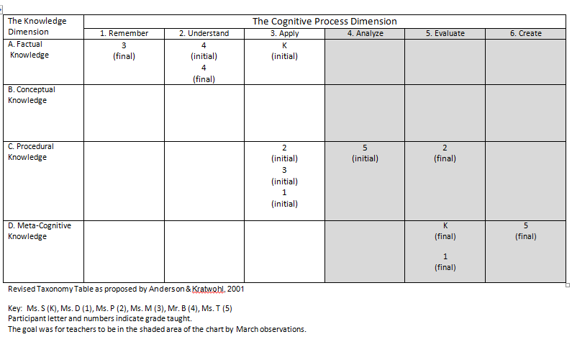
Follow-up Meetings:
Most of these meetings were celebratory ones with high fives and “way to gos”. The teachers who made it into the target area on the chart expressed the difference they saw in the student engagement when doing these lessons as compared to the first ones. Realizations were made about the students being more in charge of the Smartboard and the learning when they were engaged. Since this is only a small sample of the teachers at our school, it will be up to them, and to me, to continue to teach in this way and share their experiences with others in the hopes of encouraging more teachers to use their Smartboards in this way. As I mentioned at the beginning, these were not the Smartboard experts, so there are some teachers at school who are already using their Smartboards to engage students in these types of lessons, but there are also teachers like Ms. M and Mr. B who need a lot more consistent support to make these lessons happen in their classrooms. The experience that Ms. M and Mr. B had lends truth to what researchers Smith and Underwood (as cited in Kershner, Mercer, Warwick, & Staarman, 2010) make a point to say:
“It has been observed by researchers and teachers that the mere introduction of the IWB does not in itself have a transformative effect on classroom teaching and learning and may indeed reinforce familiar patterns of teacher-pupil interaction in whole-class teaching”. (p. 360)

Professional Development:
My initial plan was to teach four professional development courses where teachers could learn more about the Smartboard and the kinds of lessons and activities that would promote engaged learning. The concept was to have an ongoing technology professional development session that would continue to spur ideas and keep teachers excited, similar to the experience of the author Peggy Lisenbee (2008), who wrote about how she used the IWB in her classroom of pre-kindergarteners by going to interactive websites that they could use in their learning. She wrote, “The children were highly motivated and interested in using technological tools to learn, which encouraged me to find ways to incorporate technology into my teaching methods.”
Unfortunately, due to the scheduling of other professional development courses by the administration, and time constraints, I was only able to conduct one of the professional development sessions planned. I taught a beginning integration of Smartboards course in September. This was one of the tiered courses that our Professional Development Key Committee decided to have. We wanted to have courses that were differentiated based on teachers’ needs. There was a survey conducted to determine those professional development needs that were aligned with the School Improvement Plan. For the first day of tiered sessions, we had four courses: Beginning Technology, Intermediate/Advanced Technology, Beginning Writer’s Workshop, and Intermediate/Advanced Writer’s Workshop. By providing teachers with a choice of what they thought would be most beneficial to them, more teachers were willing and excited to participate in a professional development course. I was intrigued when I read an article for my mini literature review about interactive whiteboards that spoke to this same concept. Kaufman (2009) also found that when teachers were given the opportunity to participate in a school-wide professional development that was tiered in a way that allowed them the opportunity to choose the training that best fit their needs either a basic skills workshop or intermediate/advanced skills workshop, teachers were more responsive and excited about using the IWB in their classrooms. My plan is to remain on the Professional Development Committee so I can try to continue this type of learning in the future. I had a lot of positive feedback from the 12 teachers who came to my course. The surveys and personal responses, along with questions and comments weeks after the course, spurred my desire to keep the technology courses going for the teachers who need more ideas and support. As Lewin, Somekh & Steadman (2008) said, “Teachers do not necessarily need to develop high levels of technical expertise in order to transform their pedagogical practices.” (p. 301).
Student Surveys:
I decided that there was one more thing I wanted to take from this experience. I wanted to hear from some students. I asked the 5th grade teachers if they would mind having their students fill out a short survey about their experience with the Smartboard. Most of these students had been at Teasley and were some of the initial users of the Smartboards when they were installed back in February of 2010. The teachers agreed. I was provided with some good feedback for myself and the teachers at school.
Students were asked questions like:
- How often does your teacher use the Smartboard?
- In what subject areas is the Smartboard used the most?
- How often do students in your class get to interact with the Smartboard?
- Write down an activity from your class where the Smartboard was used that you found to be a good lesson.
- How do you wish the Smartboard was used in your class that would be beneficial to your learning and the learning of others?
The interaction claimed by the students was interesting. Refer to the pie charts that show the amount of times teachers use the Smartboard and the amount of times students use the Smartboards.
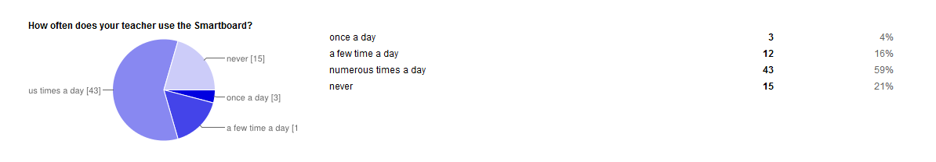
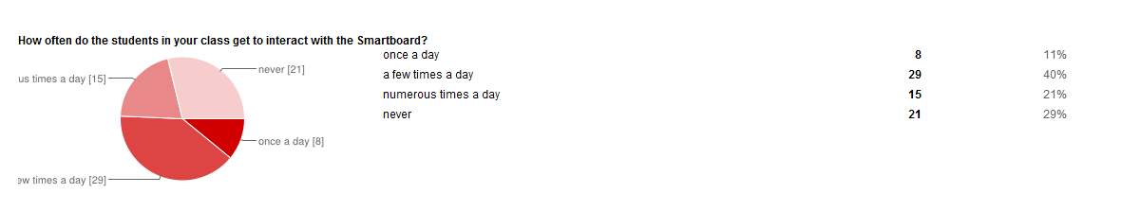
I thought the student responses for how it was used and how it could be used were very informative. When asked to write down an activity from class where the Smartboard was used that you found to be a good lesson, some students said:
- We were going over math homework. If the Smartboard hadn’t been there we would have had to keep erasing on the whiteboard. It would have been messy.
- In Science we get to see powerpoints on the board and then a lot of fun games to learn the lesson correctly.
- We only used the Smartboard once.
- Mountain math, but we didn’t touch it. The projector just projects it.
- We didn’t ever use the Smartboard.
When asked how they wished the Smartboard was used in class, students said:
- Instead of doing lessons we could use websites with activities about the lesson.
- The kids should be able to work one [problem] on the board.
- If we played games to understand the lesson.
- I wish we used the Smartboard to learn lessons at least more than once.
- We should get some time to get to use the Smartboard ourselves so we get to interact with technology and we learn stuff by writing and reading on the Smartboard.
- When we do science, math and other subjects because it would make learning more fun and kids like to have fun so if we are having fun we will pay more attention.
These comments reflect the level of impact and engaged learning that is, is not, or could be happening in the classroom. It is important to get feedback from the teachers as well as the students. I plan to use this information from the students to get the teachers to understand technology from the students’ perspective. This will be a great way to hook the teachers at the next technology professional development course I teach.
Reflection:
By doing this Capstone, I learned that teaching a class of students all day and trying to observe teachers teaching students is very difficult to do. I am so thankful to have an awesome co-teacher and principal who were willing to work with me to allow me to do what I needed to do for this project. I also learned that just because I believe I can teach everyone, that isn’t necessarily the case. I was not able to fully convert the two teachers that I took on as a challenge. I won’t be giving up Mr. B and other teachers like him. I like a challenge and will continue to provide support so that some changes can still be made. I also learned that people have different definitions and visions about what student engagement looks like, so it is important to make sure this is discussed and people are given examples so they can model their teaching and learning accordingly.
Through this experience, I addressed the shared vision standard by facilitating the development and implementation of a shared vision for the use of technology by use of the Smartboard and interactive sites in teaching, learning, and leadership. I designed and facilitated this capstone in a way that provided teaching and learning opportunities that would enhance the shared technology vision of our school in the use of Smartboard technology for student engaged lessons and activities. I helped model and facilitate the use of digital tools and resources to teachers in an authentic learning experience through a professional development course that would allow them to use these resources for authentic learning experiences for their students. The Revised Bloom’s Taxonomy chart was used to support and enhance higher order thinking skills. Differentiation was used when considering the professional development courses that allowed for teachers to choose the levels of courses that best fit their needs as a learner, while research-based best practices were used to develop the learning experiences that were taught within the courses.
The Digital Equity standard and Safe, Healthy, Legal and Ethical Use standard were both going to be addressed in one of the professional development courses I planned to teach, but were not in the Beginning Technology Smartboard Integration course I taught. I did, however, speak privately with the teacher whom I observed that initiated the Bing search during her lesson and pinpointed some reasons why that was not safe to do in plain view of the students. She said she had not considered that before and appreciated the information.
I covered all the professional learning standards in the development of a pre-course survey to determine teachers’ needs, then developed the class based on those needs and the objectives I had for this project, and finally offered an end-of-course assessment to get feedback from the teachers on how the course was helpful and could be improved.
The instructional technology education I have received prepared me to complete this capstone and served as a huge learning tool for me and for the teachers I worked with on this project. It has made me want to continue to help teachers so that they can choose activities that will engage their students in activities and lessons that are meaningful and authentic. This experience has also taught me to continue to self-monitor and reflect in my own teaching so that I make sure that my students are learning in ways that are most beneficial to them, as well. My goal is to be a life-long learner in all that I do and to exhibit that attitude to not only my students, but the other teachers around me. With that said, I will continue to be a technology leader at my school and will continue to research the ever-changing and advancing technologies so that I can offer assistance and provide more learning opportunities for my teachers and students.

References
Kaufman, D. S. (2009). How does the use of interactive whiteboards affect teaching and learning? Distance Learning, 6(2), 23-33.
Kershner, R., Mercer, N., Warwick, P., & Kleine Staarman, J. (2010). Can the interactive whiteboard support young childrens collaborative communication and thinking in classroom science activities? International Journal of Computer-Supported Collaborative Learning, 5(4), 359-383. doi:10.1007/s11412-010-9096-2
Krathwohl, David R., Autumn, 2002. A Revision of Bloom’s Taxonomy: An Overview
Lewin, C., Somekh, B., & Steadman, S. (2008). Embedding interactive whiteboards in teaching and learning: The process of change in pedagogic practice. Education and Information Technologies, 13(4), 291-303. doi:10.1007/s10639-008-9070-z
Smith, F., Hardman, F., & Higgins, S. (2006). Impact of interactive whiteboards on teacher-pupil interaction in the national literacy and numeracy strategies. British Educational Research Journal, 32(3), 443-457.

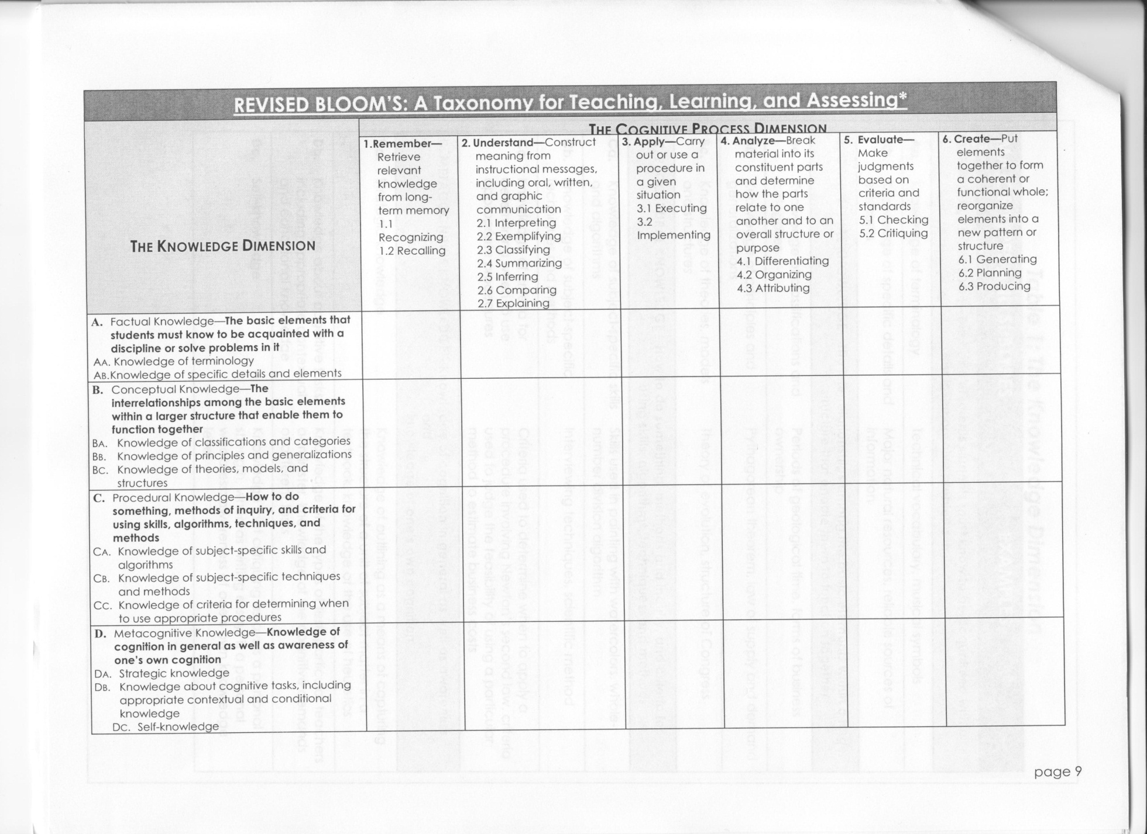

Professional Development Survey
Please answer the questions to help us get a better understanding of the professional development training that you think would be the most beneficial for the staff at Teasley Elementary.
* Required
Top of Form
Question 1 *Based on the School Improvement Goals for Teasley, in which of the areas do you think you would benefit the most from a professional development training.
- Small Group/Guided Math
- Writer's Workshop
- Smartboard/Technology
- Anti-Bullying
Question 2 *Do you think you would benefit from having the choice to attend differentiated professional development workshops?
- Yes
- No
Question 3 *If there were a Smartboard training session, which differentiated group do you think you would sign up for?
- Beginner
- Intermediate
- Advanced
Question 4 *If there were a Small Group/Guided Math training session, which differentiated group do you think you would sign up for?
- Beginner
- Intermediate
- Advanced
Question 5 *If there were a Writer's Workshop training session, which differentiated group do you think you would sign up for?
- Beginner
- Intermediate
- Advanced
Question 6If you answered "Advanced" to any of the previous three questions, would you be willing to teach a professional development training session in that area?
- Yes
- No
Question 7Based on the needs of Teasley, what other professional development course topics do you think would be helpful in achieving our School Improvement Goals or improving our school/teaching?
Bottom of Form
Powered by Google DocsReport Abuse - Terms of Service - Additional Terms

5th Grade Smartboard Questioinnaire
* Required

How often does your teacher use the Smartboard?
- once a day
- a few time a day
- numerous times a day
- never

In what subject areas is the Smartboard used the most? *
- reading
- writing
- math
- science
- social studies

How often do the students in your class get to interact with the Smartboard?
- once a day
- a few times a day
- numerous times a day
- never

Write an activity from your class where the Smartboard was used that you found to be a good lesson.

How do you wish the Smartboard was used in your class that would be beneficial to your learning and the learning of other students?

Please include any other information pertaining to the Smartboard, or technology, that you think would be important to mention.

Powered by Google DocsReport Abuse - Terms of Service - Additional Terms

